**DBMS LAB ASSIGNMENT-7**

**B NEELAKANTESWAR**

**19bcs020 T12**

1)Write two stored Procedures relevant to your database.

**Query1**:

***CREATE PROCEDURE Regional_phn_no***

***AS***

***SELECT * FROM T12_studentinfo WHERE ph_no LIKE '[9]%'***

***GO***

***EXEC Regional_phn_no;***

OUTPUT:

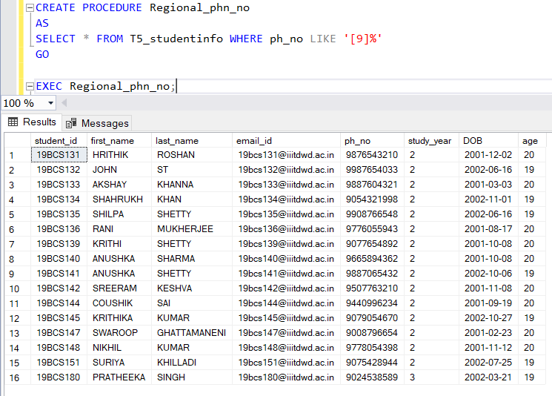

**Query2**:

*CREATE PROCEDURE avg_fee_paid_by_region*

*AS*

*SELECT address, AVG(fee_paid) AS avg_fee_paid FROM T12_parentinfo*

*GROUP BY address ORDER BY avg_fee_paid*

*GO*

*EXEC avg_fee_paid_by_region;*

OUTPUT:

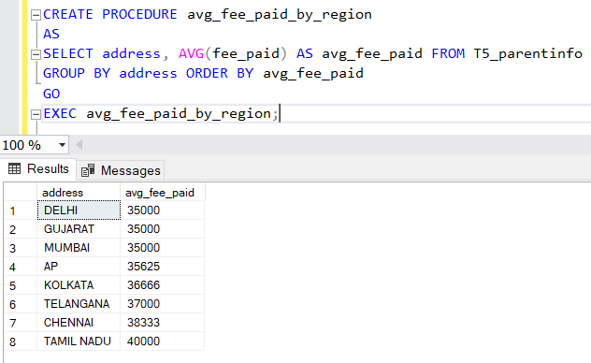

**2) Write a transaction to illustrate atomicity (related to your database).**

**Query**:

*BEGIN TRAN Transaction_grades*

*UPDATE T12_grades SET marks='92' where course_id='cs201' and student_id='19BCS133'*

*INSERT INTO T12_grades VALUES ('90','A','CS201','19BCS190')*

*COMMIT*

*SELECT * FROM T12_grades*

OUTPUT:

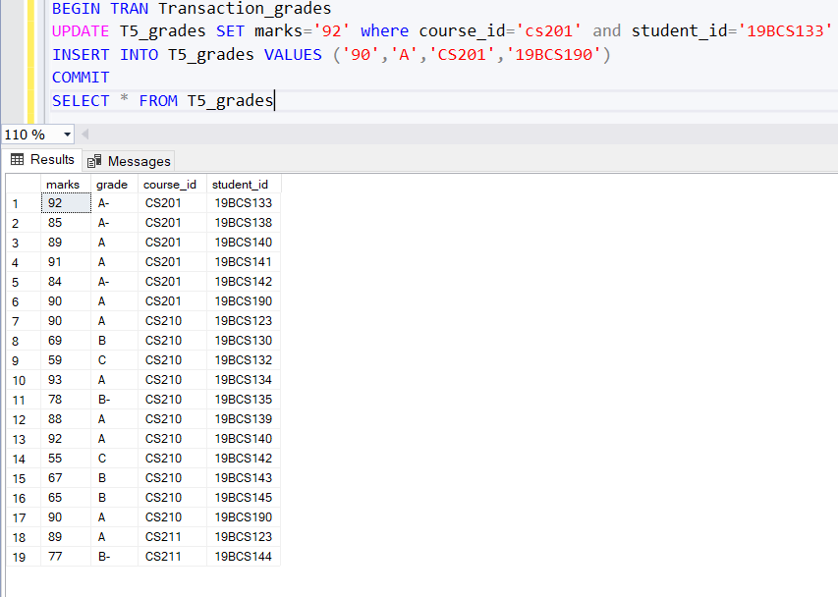

Now, let us we will insert wrong information in the T12_grades table to fail the insertion deliberately.

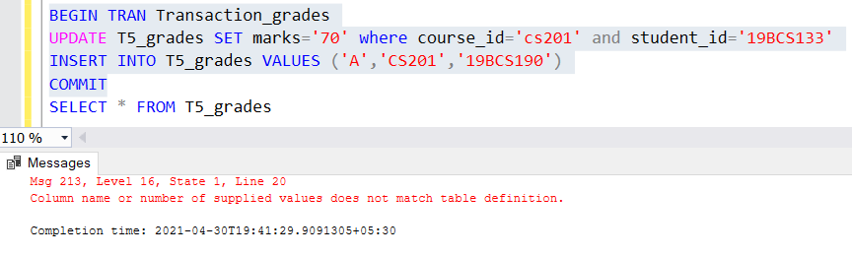

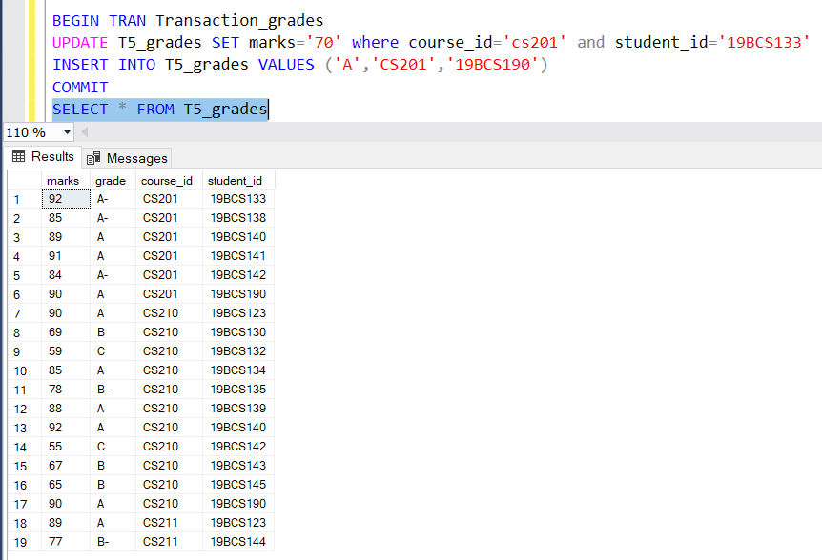

Here, we can clearly see that the transaction got rolled back as error have been occurred in insert operation. And thus, update have not been worked due to atomic property and the previous values of the table are displayed.

**3) Write a transaction to illustrate isolation level. It can be on commit or uncommit read (related to your database).**

**Query**:

*USE school;*

*GO*

*BEGIN TRAN Trans_Isolation*

*UPDATE T12_course_staff*

*SET teacher_id = 'EC02'*

*WHERE course_id = 'cs211'*

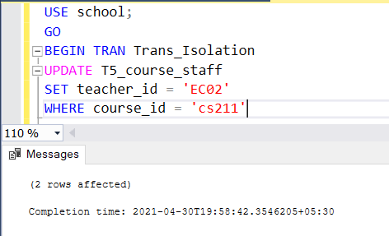

*USE school;*

*GO*

*SET TRANSACTION ISOLATION LEVEL READ UNCOMMITTED*

*GO*

*BEGIN TRAN Trans_Isolation1*

*SELECT * FROM T12_course_staff*

*WHERE course_id='cs211'*

OUTPUT:

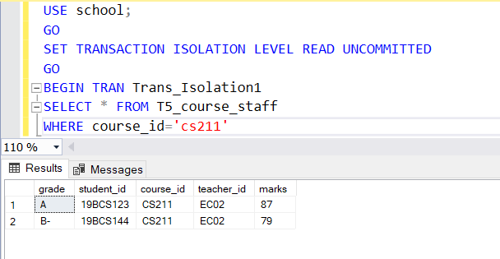

* When we set the isolation level to read uncommitted, we will be able to see the teacher_id set to ‘EC02’, called Dirty Read.